**Project Report**

**Project Title:**

**HouseHunt: Finding Your Perfect Rental Home  
  
Team Members :  
Keerthana Reddy**

Gadidimalla PrasannaS Lakshmi Bhavani

Sudhamani Yalamanchi

**1. Introduction**

**HouseHunt** is a MERN stack-based rental application designed to simplify the process of finding, booking, and managing rental homes and apartments. It serves as a digital platform for tenants, landlords, and administrators to streamline the rental process through a user-friendly interface and secure backend infrastructure.  
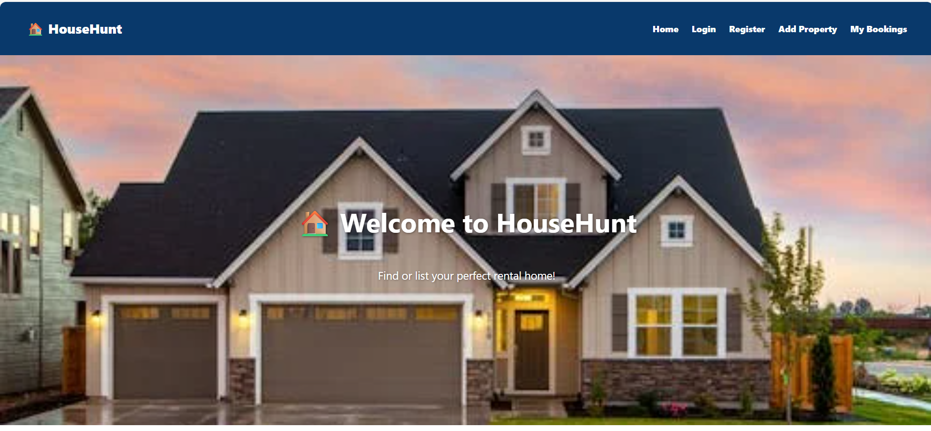

* **2. Project Overview**
* **Purpose:**  
  HouseHunt aims to simplify the process of finding and renting homes by providing a platform where renters can search, filter, and book properties seamlessly while property owners can manage listings efficiently.
* **Features:**
* User Registration & Login (Renter, Owner, Admin)
* Property Listings with images and descriptions
* Search with filters (location, price, type, amenities)
* Contacting landlords via form submission
* Admin approval for owner registration
* Owner dashboard for property management
* Booking management and notifications
* Secure lease negotiation and confirmation
* **3. Architecture**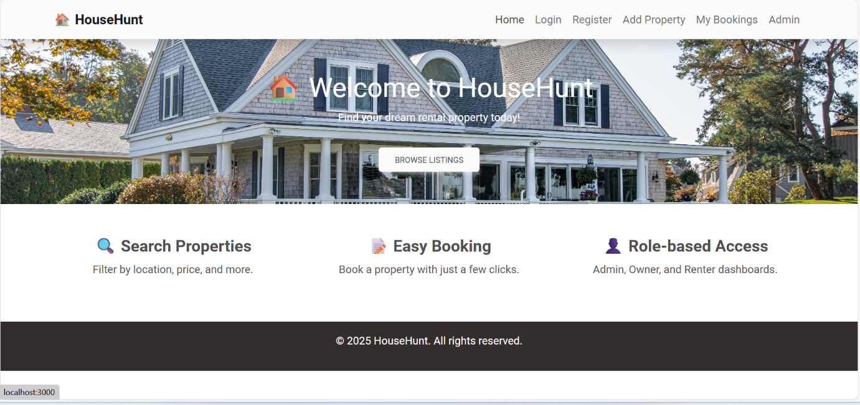
* **Frontend (React.js):**
* Built using React with routing and state management
* Axios used to make HTTP requests to backend APIs
* UI styled with Bootstrap, Material UI, and Ant Design
* **Backend (Node.js + Express.js):**
* RESTful APIs for user authentication, property management, and booking
* Middleware for error handling and authentication
* **Database (MongoDB):**
* Collections: Users, Properties, Bookings
* Mongoose used for schema design and CRUD operations  
  **REQUIREMENT ANALYSIS**
* **3.1 Customer Journey Map**
* User signs up → Browses listings → Applies filters → Views details → Sends inquiry → Books apartment → Owner confirms → Admin moderates → Deal finalized
* **3.2 Solution Requirement**
* Secure user authentication
* Efficient CRUD operations
* Seamless UX/UI
* Admin control panel
* Real-time updates and notifications
* **3.3 Data Flow Diagram**
* Frontend ↔ Express Server ↔ MongoDB
* Users interact with React components
* Backend processes requests and responses
* MongoDB stores persistent data
* **3.4 Technology Stack**
* Frontend: React.js, Bootstrap, Material UI, Ant Design
* Backend: Node.js, Express.js
* Database: MongoDB + Mongoose
* Other Tools: Moment.js, Axios
* 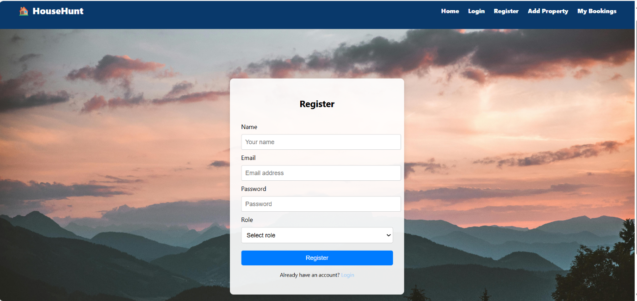  
    
  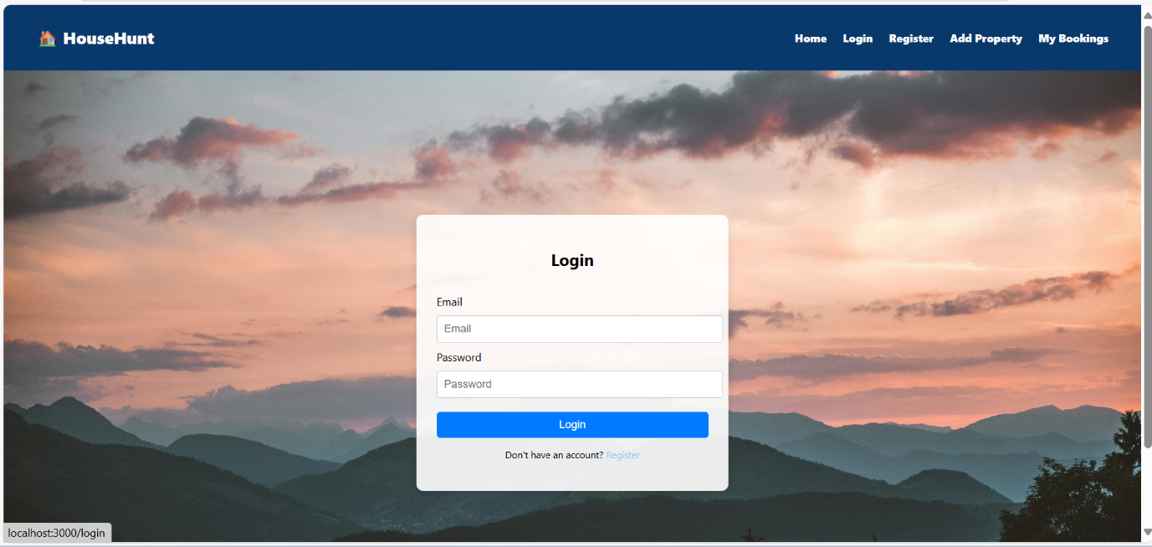

**4. PROJECT DESIGN**

**4.1 Problem Solution Fit**

* **Problem: Manual property search is time-consuming and scattered.**
* **Solution: A centralized web platform for easy rental property browsing and management.**

**4.2 Proposed Solution**

* **Web-based platform supporting renters, owners, and admin workflows.**
* **End-to-end booking and management system.**

**4.3 Solution Architecture**

* **Client-Server architecture**
* **RESTful API interaction**

**5. Technical Architecture**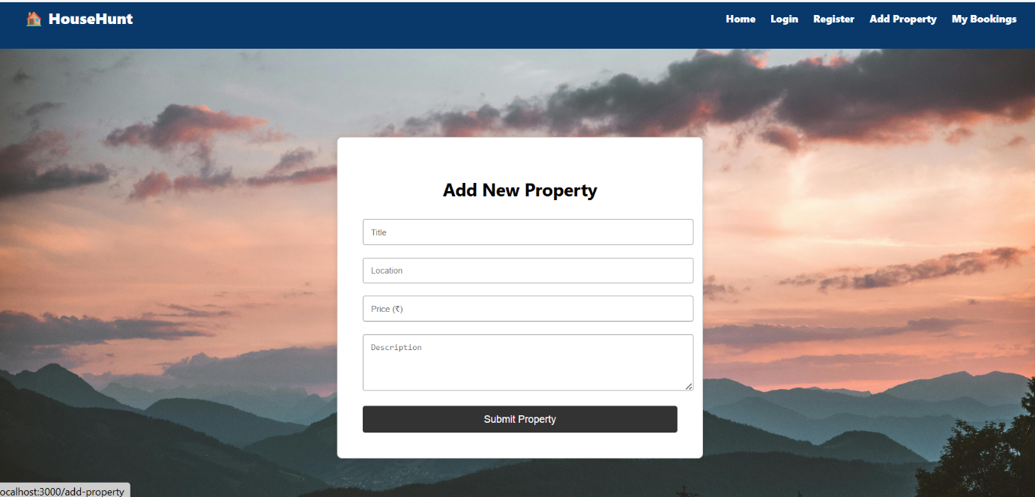

HouseHunt follows a client-server architecture comprising:

**Frontend (Client):**

* **React.js**: User interface development.
* **Axios**: Handles HTTP requests to the backend.
* **Bootstrap & Material UI**: Responsive and consistent UI components.
* **Ant Design**: Enhanced UI elements and design systems.

**Backend (Server):**

* **Node.js + Express.js**: RESTful API, routing, middleware.
* **MongoDB**: Document-oriented NoSQL database for users, properties, and bookings.
* **Mongoose**: ODM for MongoDB schema modeling.
* **Moment.js**: Date formatting and manipulation.  
  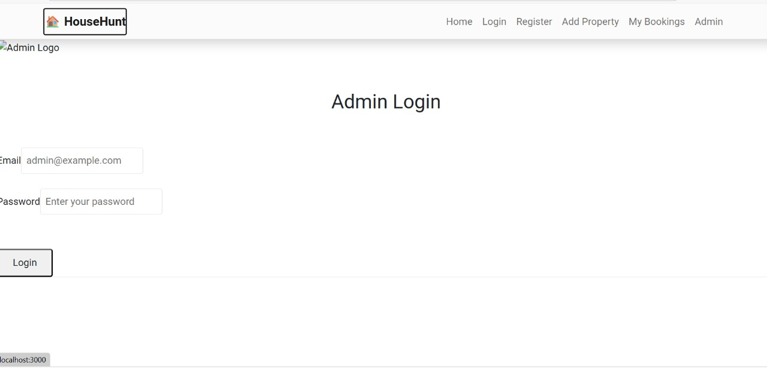

**7. Pre-requisites**

To develop and run HouseHunt, the following tools and libraries are essential:

| **Tool** | **Purpose** |
| --- | --- |
| **Node.js &npm** | JavaScript runtime and package manager |
| **Express.js** | Backend framework for routing and APIs |
| **MongoDB** | NoSQL database |
| **Mongoose** | MongoDB ODM for schema modeling |
| **React.js** | Frontend UI framework |
| **Axios** | HTTP client for REST calls |
| **Bootstrap & Material UI** | Styling UI components |
| **Ant Design** | Advanced UI components |
| **Moment.js** | Date/time formatting |
| **HTML, CSS, JavaScript** | Core web technologies |

**8. Installation & Setup**

**Step 1: Clone Repository**

bash

CopyEdit

git clone <your-repo-url>

**Step 2: Install Dependencies**

bash

CopyEdit

cd house-rent

cd frontend

npm install

cd ../backend

npm install

**Step 3: Start Development Servers**

bash

CopyEdit

# Frontend (React)

cd frontend

npm start

# Access: http://localhost:3000

# Backend (Express)

cd ../backend

npm start

# Runs on default backend port (e.g., 5000)

**10.ADVANTAGES & DISADVANTAGES**

**Advantages:**

* Intuitive and clean UI
* Role-based access and workflows
* Real-time property updates
* Centralized management and governance

**Disadvantages:**

* No offline mode
* Limited to web (no native mobile app yet)

Relies on internet connectivity  
**11. Conclusion**

**HouseHunt** effectively bridges the gap between property seekers and owners, enabling a digital-first approach to renting homes. Its modular design, strong backend, and rich UI experience make it scalable and reliable for real-world use cases. The platform not only simplifies the rental journey but also ensures transparency, safety, and trust among its users.

**12. FUTURE SCOPE**

* Add payment integration
* Develop a mobile application
* Enable geolocation-based searches
* Integrate AI recommendations based on user behavior
* **13. APPENDIX**

**Source Code:**  
**GitHub & Project Demo Link : https://github.com/GeethaPranathi/HouseHunt-Finding-Your-Perfect-Rental-Home.git**